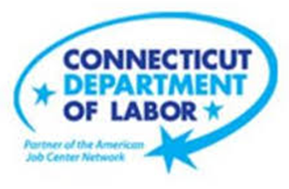

**NEW WEEKLY JOB POSTINGS FROM   
HELP WANTED ONLINE  
Office of Research**

**Week Ending July 23rd, 2022: New Ads Down 10% Over the Week But Remain Above 10,000**WETHERSFIELD, July 29th, 2022 – During the week ending July 23rd, there were 10,041 new postings, down 1,065 new ads or -10% over the week. Employers with large over the week decreases include Capital One (-138 new ads), Thrieworks (-111 new ads), and ConnectRN (-92 new ads). Occupations with the largest over the week decreases include Retail Salespersons (-77 new ads), Pharmacy Technicians (-69 new ads), and Real Estate Sales Agents (-52 new ads). Though down over the week, weekly new ads have been over 10,000 for three weeks in a row. The last time the state had 3 weeks over 10,000 was May 2022. With one week to go in the month, the four weeks ending in July have averaged 10,286 new ads per week.  
  
  
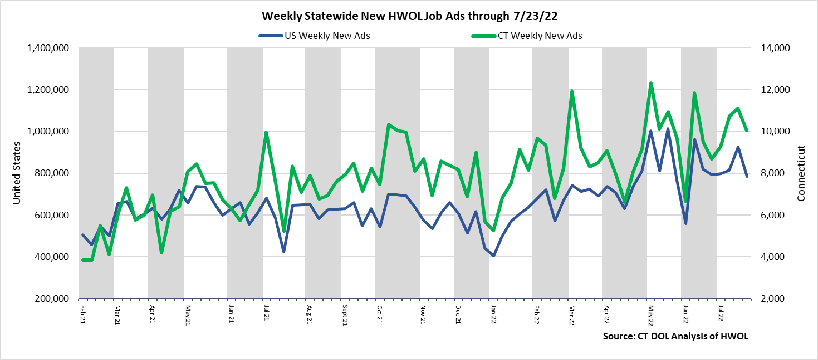  
**Industries** with the most new postings include Health Care & Social Assistance, Pro., Sci., & Tech. Services, and Finance & Insurance.

**Occupations** with the most new postings include Registered Nurses, Heavy & Tractor Trailer Truck Drivers, and Supervisors of Retail Salespersons.

**Employers** with the most new postings include Deloitte, PricewaterhouseCoopers, and KPMG.

**The three industries with the most new job postings were:**

* **Health Care & Social Assistance** (1,954 new postings, -8% over the week)
* **Professional, Scientific, and Technical Services** (1,131 new postings, +7% over the week)
* **Finance and Insurance** (925 new postings, -16% over the week)

  
 During the week ending July 23rd, 2022, the total ad decrease of 1,065 new ads or -10% is the net result of decreases in 15 of 21 industries. This 10% top-line decrease overlays larger industry level change. 13 industries had decreases of 12% or more and 8 had decreases of over 20%. The largest decreases occurred in Retail Trade (-309 new ads) and Health Care & Social Assistance (-178 new ads). The 6 industries with increasing ads over the week had a combined 237 new ad increase, with over half that occurring in Pro., Sci., & Tech. Services (+74 new ads) and Educational Services (+51 new ads). Over four weeks, total new ads are up 16% or +1,348 new ads. Fourteen industries had four week increases, one was unchanged, and six had decreases. The Largest four week gains include Pro., Sci., & Tech Services (+521 new ads), Accommodation & Food Services (+245 new ads), and Transportation & Warehousing (+239 new ads).  
   
 For more information on total job ads by industry for Connecticut and its labor market areas, see the monthly report available here: <https://www1.ctdol.state.ct.us/lmi/hwol.asp>

**New Job Postings by Occupation** 

**The occupations with the most new postings were:**

* Registered Nurses (459 new postings, +6% over the week)
* Heavy & Tractor Trailer Truck Drivers (340 new postings, -11% over the week)
* Supervisors of Retail Salespersons (208 new postings, -13% over the week)

**Employers with the Most New Job Postings**

Employers with the most new job postings during the week were mostly in Healthcare & Social Assistance, Finance & Insurance, and Pro., Sci., & Tech. Services. The 25 employers shown above account for 19 percent of all new ads. 16 of 25 employers in the top 25 had over the week increases. The largest increases in the top 25 include PricewaterhouseCoopers (+133 new ads), Stamford Hospital (+94 new ads), and Starbucks Coffee Company (+88 new ads). The largest decreases over the week include Capital One (-138 new ads) and Yale-New Haven Health System (-85 new ads). Over four weeks, 16 employers in the top 25 had increases and 9 had decreases. The largest four week increase was Deloitte (+291 new ads) and the largest decreasing employer was Community Health Center (-230 new ads).  
  
**What is HWOL?**The **Conference Board Help Wanted Online**® Data Series (HWOL) measures the number of new, first-time Online job postings and jobs reposted from the previous month for over 16,000 Internet job boards, corporate boards and smaller job sites that serve niche markets and smaller geographic areas. To view more HWOL data, go to: <https://www1.ctdol.state.ct.us/lmi/hwol.asp>